**Instruction Manual**

Menu Screen

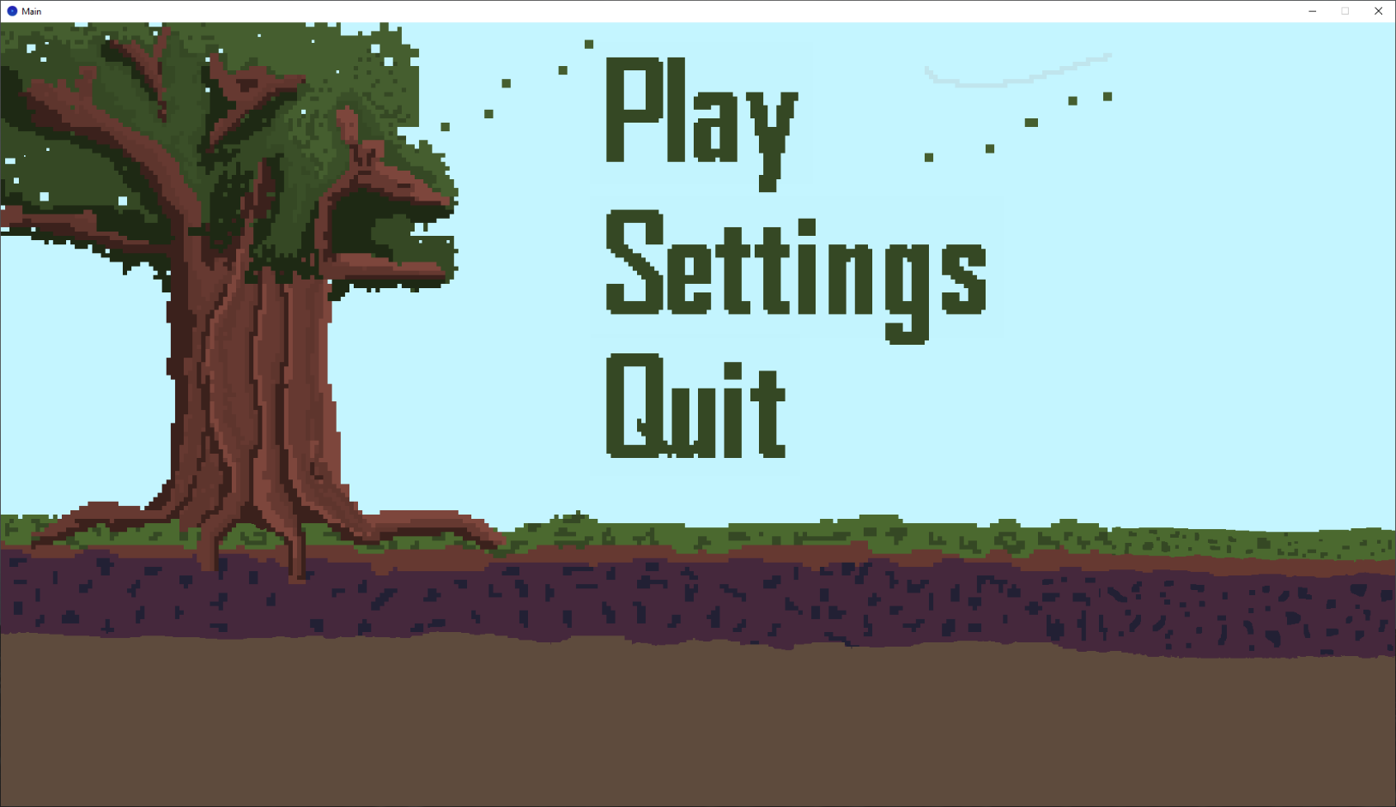Navigate with [Mouse Clicks]

Menu Screen [Mouse Click] Quit

Chance to confirm whether you would like to quit game or not

May either [Mouse Click] No or [Key Press] ESC to go back to Menu Screen

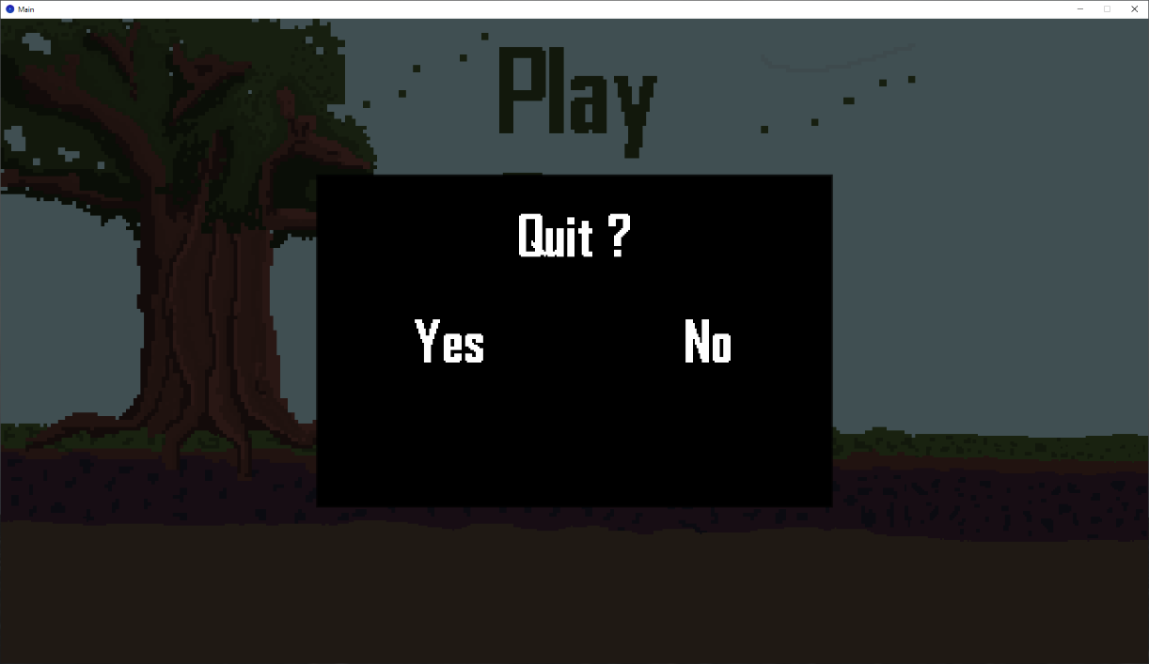[Mouse Click] Yes will quit game window

Menu Screen [Mouse Click] Settings

Music and SFX Volume Sliders to adjust volume

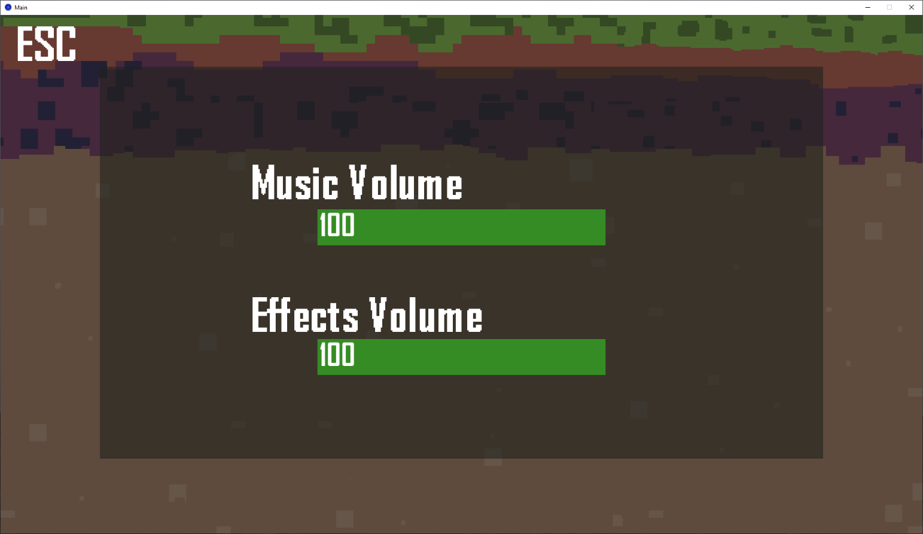May either [Mouse Click] ESC (in the left corner) or [Key Press] ESC to go back to Menu Screen

Menu Screen [Mouse Click] Play

Difficulty Selection Screen – choose difficulty of game with [Mouse Click]

May either [Mouse Click] ESC (in the left corner) or [Key Press] ESC to go back to Menu Screen

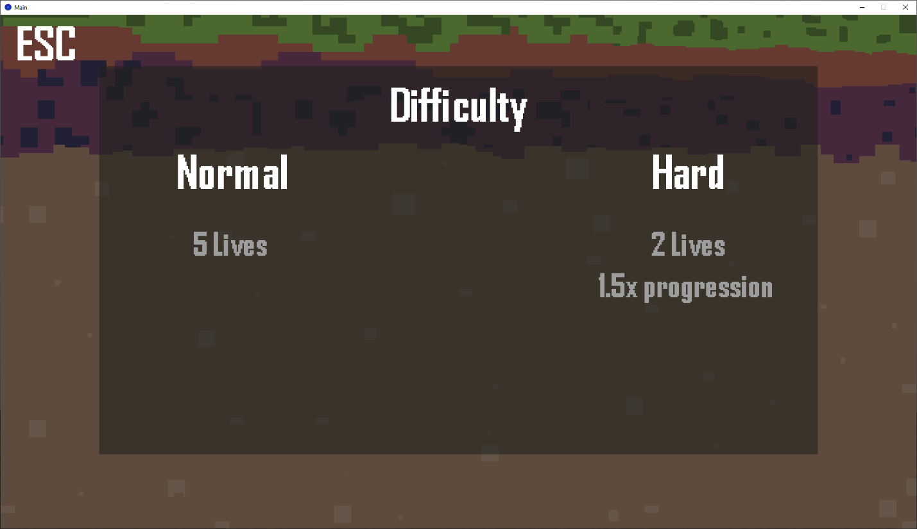

Difficulty Screen [Mouse Click] Normal || Hard

Begins Game Play

Note: Overlay : Health, Kills, and Level

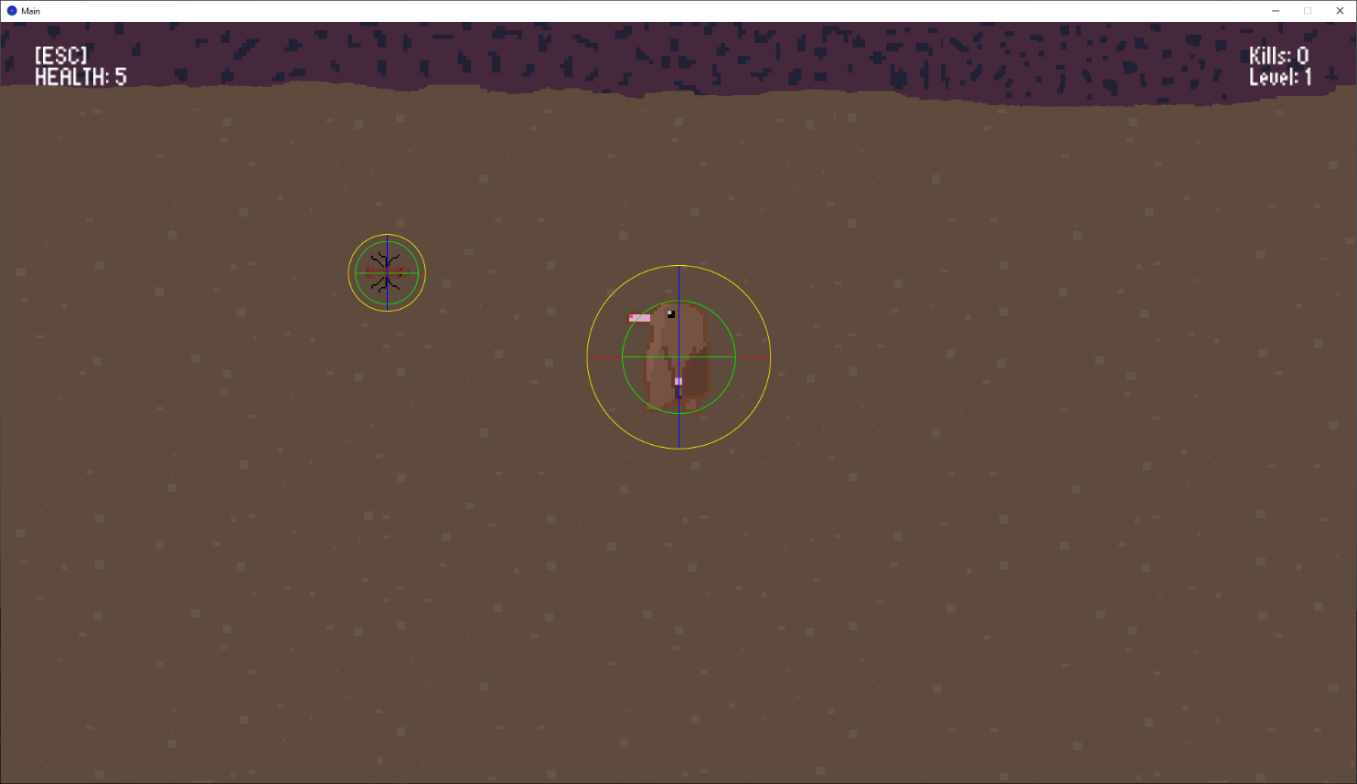

[Key Press] ESC to enter In-Game Settings

Music and SFX Volume Sliders to adjust volume with Mouse Press

May either [Mouse Click] Resume or [Key Press] ESC to go back to Game

[Mouse Click] Quit to Menu to quit game and go to Menu

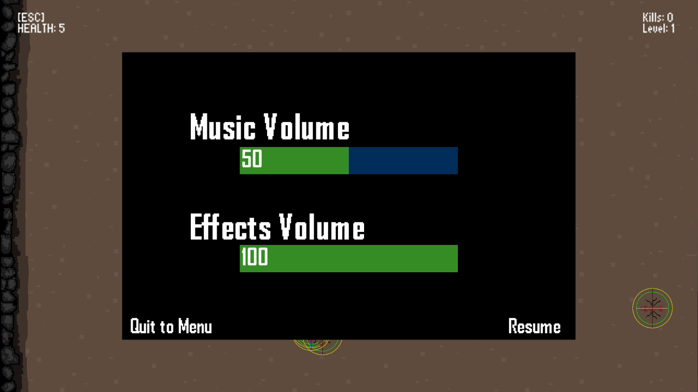

Game Movements

WASD Key input will control direction of character

W – Up



S – Down



A – Left



D – Right



Diagonal Movement

[Mouse Click] will prompt Player to attack



On Increase of Level, UPGRADE Screen will show

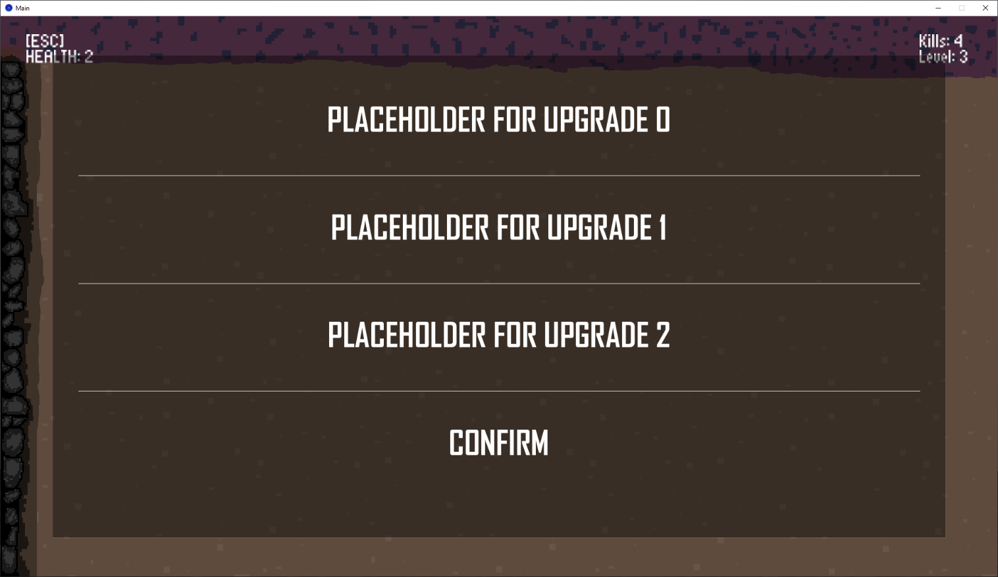

[Mouse Click] on Upgrade to Select it

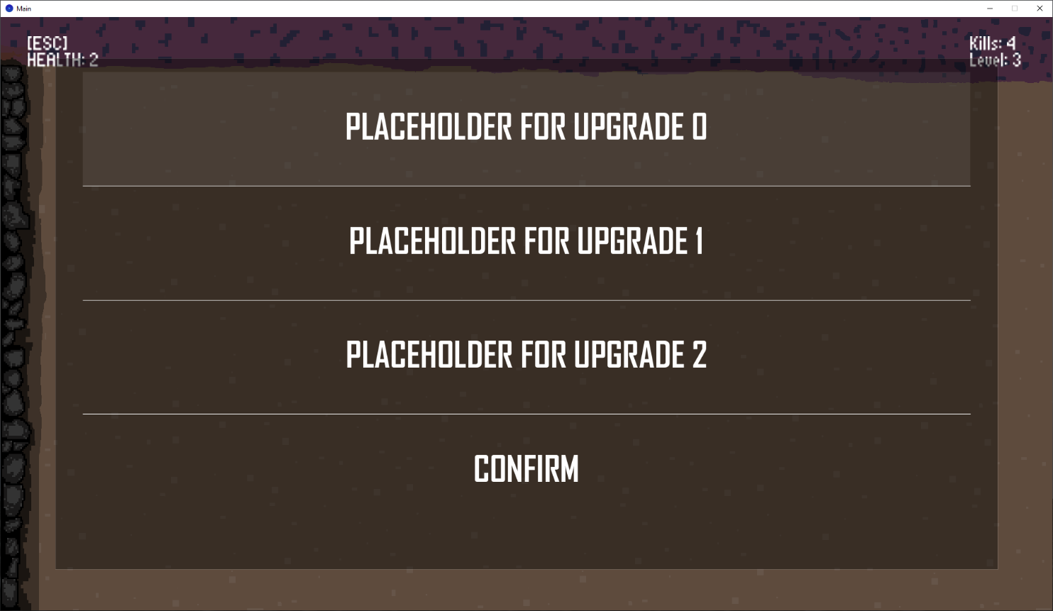

[Mouse Click] Confirm to confirm selection and resume game

